**CP Club 365Days Challenge**

**Date – 11/12/2022**

**Programming language – c++**

**Problem Statement**

**[https://practice.geeksforgeeks.org/problems/game-with-nos3123/1?page=1&difficulty[]=-1&category[]=Arrays&sortBy=accuracy](https://practice.geeksforgeeks.org/problems/game-with-nos3123/1?page=1&difficulty%5b%5d=-1&category%5b%5d=Arrays&sortBy=accuracy)**

**Your Code**:

// 0x55Day of 0x365Days challenge

// VEDANT BHARAD

// 11-12-2022

//{ Driver Code Starts

#include<bits/stdc++.h>

using namespace std;

int* game_with_number(int arr[], int n);

int main()

{

    int t;cin>> t;

    while(t--)

    {

        int n;

        cin >> n;

        int arr[n];

        for(int i=0;i<n;i++)

            cin>>arr[i];

        int *arr2;

        arr2 = game_with_number(arr, n);

        for(int i = 0;i < n; i++)

            cout << arr2[i] << " ";

        cout << endl;

    }

}

// } Driver Code Ends

int* game_with_number(int arr[], int n)

{

    for(int loop = 0; loop < n-1; loop++)

    {

        arr[loop]=arr[loop]^arr[loop+1];

    }

    return arr;

}

**Output (Screen Shot)**:

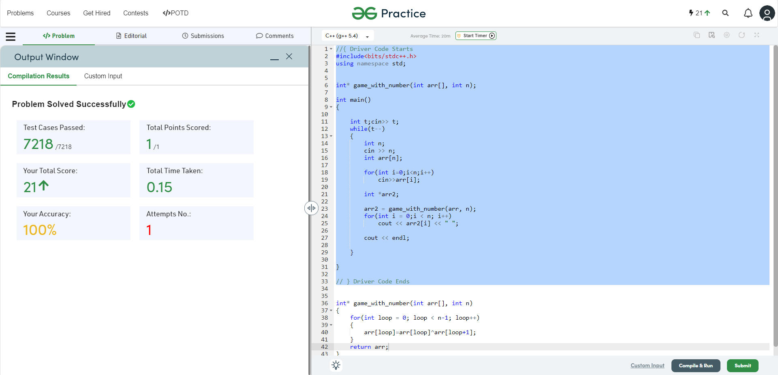

**Understanding about problem:**

* In this task I need to do only XOR of array index with current and current +1 for n-1.

Note: If you can't understand the problem, feel free to contact us and we'll help you. Please don't copy and paste from anywhere.

ALL THE BEST

Team CP Club